



Palace rejects Arviyan Arifin for PLN to post
The State Palace has reportedly rejected the nomination of Arviyan Arifin to lead state-owned electricity company PLN because of his role in causing Bank Muamalat’s deep financial difficulties. The State-Owned Enterprises Ministry will need to propose another name to President Joko “Jokowi” Widodo.

Govt gives Pertamina three-year transition to operate Corridor
The government has given its blessing to US oil and gas company ConocoPhillips to remain the operator of the onshore Corridor block in South Sumatra until 2026. It is reported that the reappointment of ConocoPhilips as the operator of the Corridor block after the contract expired in 2023 was a middle ground before the operatorship of the oil and gas area was handed over to Pertamina.

The Fed delivers rate cut, but Powell’s speech disappoints market
The United States Federal Reserve cut the Fed Funds Rate by 25 basis points (bps) to the 2–2.25 per-cent range following the Federal Open Market Committee (FOMC) meeting from 30–31 July. Never-theless, the market reacted unfavorably with a selloff.
PT Pos struggles with cash flow and employee benefits
Postal services all over the world, including Pos Indonesia, reportedly suffered under technological disruption due to the rise of e-commerce. In the case of Pos Indonesia, cashflow issue and the management’s attempt to cut back employee benefits might be the main culprits.

Four routes to Jokowi’s new cabinet
As speculation and rumors surrounding President Joko “Jokowi” Widodo’s plan to reshuffle his cabinet fly around, political lobbies among the elites for the ministerial posts are still ongoing. Those who are interested can reportedly secure the posts through four “channels”.

PKB, PPP fight over religious affairs minister seat
Tensions have simmered between political parties as reelected President Joko “Jokowi” Widodo prepares his upcoming cabinet. Engaged in the latest din were the National Awakening Party (PKB) and the United Development Party (PPP), with both parties fighting over the religious affairs minister seat.
Jokowi a step closer to dissolving hardline group
Since its permit expired on June 20, hardline mass organization the Islam Defenders Front (FPI) has been waiting for the government to grant its request for a permit renewal. While the government has yet to announce its final decision, President Joko “Jokowi” Widodo recently spoke of the huge possibility for the government to not extend the group’s permit.

All Megawati’s men
An unexpected meeting between Indonesian Democratic Party of Struggle (PDI-P) matriarch Megawati Soekarnoputri and Gerindra chairman Prabowo Subianto proves that Megawati still has what it takes. Megawati, however, does not navigate her way alone; several notable men have flanked her maneuvers.

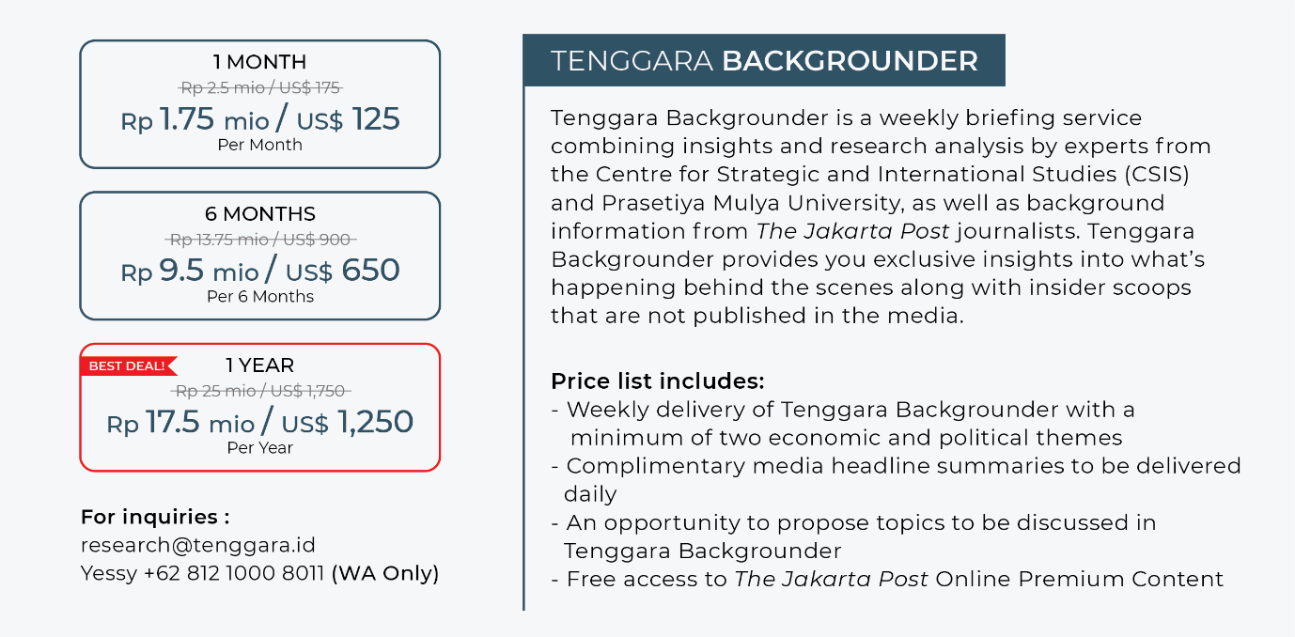POLITICS

All Megawati’s men
OVERVIEW
An unexpected meeting between Indonesian Democratic Party of Struggle (PDI-P) matriarch Megawati Soekarnoputri and Gerindra chairman Prabowo Subianto proves that Megawati still has what it takes. Amid reported squabbling between President Joko “Jokowi” Widodo, his coalition parties and the opposition parties over the new cabinet, Megawati’s encounter with Prabowo brings her back into the spotlight, showing the public her stature as perhaps the most influential power broker.

Megawati, however, does not navigate her way alone; several notable men have flanked her maneuvers.

First is her son and head of the PDI-P creative economy division, Prananda Prabowo. Despite having been relatively obscure vis-à-vis his more politically savvy sister, Puan Maharani, Prananda started to rise to prominence when news about his immediate nomination as PDI-P executive chairman circulated. Prananda could be Megawati’s vehicle to preserve her father’s, Indonesia’s first president Sukarno, lineage within the PDI-P, which is reportedly divided between Sukarno loyalists and those who are against political dynasty.

Second is cabinet secretary and PDI-P senior executive Pramono Anung. Pramono reportedly played a crucial role as the liaison between Jokowi and Prabowo and between Megawati and Prabowo prior to their meetings. Popularly known as menteri titipan ibu (Megawati’s minister), Pramono admitted his posting as the cabinet secretary was to bridge Megawati and Jokowi and mediate any possible challenges that could hurt ties between the two. Indeed, Pramono is known for his knack for lobbying and maintaining good relationships, including with the opposition; the Megawati-Prabowo meeting was reportedly, to a large extent, orchestrated through Pramono’s good relationship with Gerindra Party secretary-general Ahmad Muzani.

Probably the most notable man in Megawati’s circle is State Intelligence Agency (BIN) chief Budi Gunawan. His close ties with Megawati started in 1999, when he was recruited as personal adjutant of Megawati, who was the vice president then. Megawati reportedly played a crucial part in Budi’s nomination for the National Police chief post in 2015. Now, Budi’s role in arranging the Jokowi-Prabowo and Megawati-Prabowo meetings has made him the man of the hour. Some have even predicted Budi to take over the role of a fixer from Coordinating Maritime Affairs Minister Luhut Pandjaitan.

Prananda, Pramono and Budi will likely keep gaining prominence as Megawati continues her maneuvers. It would be unsurprising, too, if the three secure strategic posts in Jokowi’s next cabinet.



Politicians often have two options: to thrive or perish. Megawati is no exception. The skyrocketing political weight of President Jokowi and the increasingly aggressive demands of the coalition parties might have given Megawati no other option but to strike back.

In preserving her political influence, Megawati must act in two domains, namely in the PDI-P and domestic politics at large. This is where the roles of Prananda, Pramono and Budi differ.

Prananda is tipped to ensure the continuity of Sukarno’s familial line with the party by gradually taking over Megawati’s role as chair. Such a duty is particularly important if reports about PDI-P infighting between members loyal to the Sukarno clan and independent members, who are represented by President Jokowi, are true. Now that Jokowi has secured his second term, Megawati might fear Jokowi’s clout would triumph over hers within the party domain.

Regardless, the PDI-P must handle its regeneration with care. Having led the party since 1999, Megawati is a unifying figure who can consolidate the mixed bags of members in the PDI-P. Her successor, thus, must rival her. As it is still questionable whether Prananda has such competence, the possibility of his taking over the PDI-P chairmanship at once remains unlikely, especially now that independent members might take the party’s helm during the peak of Jokowi’s political career. Prananda’s near promotion as PDI-P executive chairman might be intended to facilitate the Sukarno clan’s regeneration process.

While Prananda’s role is to “secure” the party’s domain, Pramono’s and Budi’s role might have a greater scope, which is preserving Megawati’s influence in domestic politics at large. This might be done by preserving Megawati’s direct access to the President. In this case, Pramono’s position as the cabinet secretary would greatly benefit Megawati as he would provide her a clear overview of Jokowi’s presidential duties and the figures involved. This might be why Megawati has allegedly requested Jokowi for veto power in appointing the cabinet secretary post.

Likewise, coming under the public spotlight in recent weeks, Budi’s success in arranging the reconciliatory meetings between Jokowi-Prabowo and Megawati-Prabowo has showered him with praise. While many would know exactly Budi’s role in realizing the meetings, it is reported that Budi managed to “woo” Prabowo after releasing the latter’s detained supporters and offering Gerindra ministerial posts should the party join Jokowi’s coalition.

The fact that Budi has been compared with Jokowi’s frequent “fixer” Luhut might not be a coincidence. Luhut’s attempts to arrange a meeting between Jokowi and Prabowo have been fruitless. The absence of Luhut in the Jokowi-Prabowo and Megawati-Prabowo meetings have also led some to speculate Luhut’s diminishing role in behind-the-scenes negotiations between the elites.

Having Budi, her right-hand man, replace Luhut, a rouge player, Megawati could ensure her direct connection with Jokowi. The presence of Budi, coupled with Pramono’s, in the government could additionally create a bulwark between Jokowi and any “external influences”. Indeed, Megawati allegedly has identified certain figures in Jokowi’s circles that had built a wall between her and Jokowi, dubbing the figures a “trio of tigers”, referring to Luhut, former cabinet secretary Andi Widjajanto and State-Owned Enterprises Minister Rini Soemarno.

When Budi steals Luhut’s spotlight, Pramono maintains the cabinet secretary seat and Prananda rises within the PDI-P, it is safe to say that Megawati’s political stature will remain strong as a former president and chairwoman of the strongest party in the country. All Megawati’s men will surely strike again in the near future.



The meetings between President Joko “Jokowi” Widodo and Gerindra Party chairman Prabowo Subianto and Indonesian Democratic Party of Struggle (PDI-P) chairwoman Megawati Soekarnoputri and Prabowo saw the spotlight fall on several figures whose names have often circulated around Teuku Umar, Megawati’s residence. Two of these figures are from outside the Sukarno clan, yet still wield considerable political influence.

Budi Gunawan was reportedly trusted by Megawati to resolve the deadlock between the Prabowo and Jokowi camps following the 2019 presidential election. Budi was finally able to approach Prabowo after two PDI-P members met with two of their close friends from the Gerindra Party who were also close to Prabowo. Two of these figures were PDI-P’s Pramono Anung and Gerindra’s Ahmad Muzani, whose political careers started back in 2009 when Megawati ran for president with Prabowo as her running mate. Gerindra’s Edhie Pramono also reportedly met an unnamed close friend from the PDI-P prior to the Jokowi-Prabowo and Megawati-Prabowo meetings.

These figures facilitated the connection between the Prabowo and Jokowi camps after Coordinating Maritime Affairs Minister Luhut Pandjaitan failed to establish a connection due to a “barricade” of military generals around Prabowo. Prabowo is reported to have finally met with Luhut after the Idul Fitri holiday last July. However, the meeting occurred after Budi and the aforementioned four party elites had met each other.

Luhut is a representative of President Jokowi, while Budi, Pramono and the one unnamed PDI-P elite involved in arranging the meetings are representatives of Megawati. “So you know, then, what kind of deals they were discussing,” said a business player, who is also a senior politician. The source was implying that the meetings between Megawati, her representatives and Prabowo did not merely focus on short-term objectives such as the formation of Jokowi’s new cabinet or money, but rather on long-term political goals. “They had already discussed 2024 [presidential election]. It seems that they want to repeat what happened in 2009,” said the source.

Meanwhile, Pramono, who is a member of Megawati’s inner circle, is reportedly enjoying the benefits of the improving relationship between Jokowi, Megawati and Prabowo especially as his lobbying assisted Budi considerably in approaching Prabowo. “Since the beginning, Pramono has always been close [to political elites]. He can approach Megawati directly. He can also approach Puan [Megawati’s daughter],” said a senior PDI-P politician. Now, the source added, Pramono is also close to Megawati’s son, Prananda. “He has returned,” said the source.
What the source meant by “returning” is that Pramono has begun taking advantage of his current role as the cabinet secretary to conduct political lobbying, as he had done when actively taking part in the PDI-P. However, Pramono, for a period of time, stepped away from his role in the PDI-P, resulting in an estranged relationship with Megawati before his recent “return”. “[Pramono returned] before the 2019 legislative election. Pramono helped [the PDI-P prepare for the legislative election], including picking candidates,” said the source. Pramono, along with Megawati, Puan, Prananda, Budi and PDI-P secretary-general Hasto Kristiyanto, had the final say in determining which candidates were nominated for the election.

Meanwhile, Prananda has reportedly been trusted as PDI-P’s “think tank” since the party’s national working meeting (Rakernas) back in 2013. During the Rakernas, the PDI-P was preparing Jokowi to compete in the 2014 presidential election. “The plan, however, was not yet definite [before the Rakernas]. But Megawati firmly supported Jokowi as a presidential candidate after the meeting,” said a senior PDI-P politician.

Prananda reportedly lead a special unit within the PDI-P, whose main job is to monitor the maneuvers of other political parties. “He’s like a deputy chairman. He has considerable power,” said the source. Because of this, after PDI-P’s congress this month, Prananda will be reportedly elected as one of the leaders of PDI-P’s central executive board (DPP). “He will hold two positions, one of which is in the party’s very inner circle, while the other is in the party’s outer structure,” added the source.

Other than drawing up PDI-P’s agendas, Prananda is also reportedly tasked to prepare Megawati’s speeches. Every speech is formulated in line with Sukarno’s teachings, which have been studied by Prananda since he was young. “He has mastered everything related to Sukarno,” said the source.

Issue update: Four routes to Jokowi’s new cabinet
OVERVIEW
As speculation and rumors surrounding President Joko “Jokowi” Widodo’s plan to reshuffle his cabinet fly around, political lobbies among the elites for the ministerial posts are still ongoing. Those who are interested can reportedly secure the posts through four “channels”, namely through the Indonesian Democratic Party of Struggle (PDI-P), Jokowi’s group of volunteers, Jokowi’s national campaign team and the military.

Being the party that “delivered” Jokowi to prominence, it comes as no surprise that the PDI-P remains a powerful player in shaping the political constellation. The recent rise of PDI-P chairwoman Megawati Soekarnoputri into the political spotlight following her meeting with Gerindra Party chairman Prabowo Subianto, which many have speculated was intended to discuss power sharing between the PDI-P and Gerindra, parties with the two largest numbers of votes in the legislative election, in the next five years.

Other than the PDI-P, other coalition parties supporting Jokowi and running mate Ma’ruf Amin also provide an effective channel for interested individuals, particularly party members, to secure ministerial posts. Indeed, the channel provided by the coalition parties appear to be the most popular one, with Jokowi-Ma’ruf coalition parties having nominated dozens of their members.
It seems, however, that the alleged competition between the coalition parties in winning ministerial posts has made the channel provided by coalition parties uncertain. Recent news about an internal discord between particular coalition parties, for instance, hint at instability within the coalition.

Those who do not want to get entangled in political parties’ intrigue might resort to another possible channel, namely the military. The interconnectedness between the politics and the military in Indonesia goes back to the New Order era, during which the military was fused into the political and social landscape, granting the military supreme authority. Although the military no longer holds such a significant position in the country’s political landscape since the end of the New Order, the remnants of the military’s power are still enduring, suggested by the presence of a considerable number of military strongmen in the government.

Jokowi’s administration itself has been criticized for its alleged close relationship with the military. The presence of certain military-affiliated figures such as Coordinating Maritime Affairs Minister Luhut Pandjaitan, Coordinating Legal, Political and Security Affairs Minister Wiranto and Presidential Chief of Staff Moeldoko in Jokowi’s cabinet, for instance, has been criticized by the public, considering their strong military backgrounds.

The channels provided by the PDI-P, coalition parties and the military, however, might be a tad exclusive in nature, in a sense that these three channels might prefer party members and military figures to nominate for ministerial posts. Those who do not come from the preferred backgrounds could recourse to the last possible channel, namely the one provided by Jokowi’s group of volunteers. Organized and run mostly by civilians, Jokowi’s volunteers play a considerable part in leading him to victory in both the 2014 and 2019 presidential elections. Jokowi himself has acknowledged the importance of the volunteers by granting them the same privilege with political parties in nominating candidates for the new cabinet.

To date, 35 of the 48 names proposed for President Joko “Jokowi” Widodo’s new Cabinet have passed a screening process conducted by State Intelligence Agency (BIN) chief Budi Gunawan. These names have been deemed worthy to fill ministerial posts. Budi was entrusted by Indonesian Democratic Party of Struggle (PDI-P) chairwoman Megawati Soekarnoputri and her son, Prananda, to screen the possible candidates.

The PDI-P will reportedly hold the largest number of ministerial posts in Jokowi’s new Cabinet. For instance, Maritime Affairs and Fisheries Minister Susi Pudjiastuti and Defense Minister Ryamizard Ryacudu, who are close to the PDI-P, will reportedly retain their ministerial posts in Jokowi’s new Cabinet.

On the other hand, from Jokowi’s coalition parties, the individuals that have been nominated for ministerial posts are mostly party cadres. NasDem Party secretary-general Johnny G. Plate and National Awakening Party (PKB) secretary-general Hanif Dhakiri, for instance, are reportedly among those being considered. Meanwhile, Golkar Party chairman Airlangga Hartarto reportedly still has a chance to negotiate for a place in Jokowi’s Cabinet, specifically the coordinating economic minister post. “But Jokowi wants to give this post [coordinating economic minister] to [current Finance Minister] Sri Mulyani [Indrawati],” said a source from the Golkar Party.

At the same time, a faction within Jokowi’s national campaign team has also nominated four major business players for the President’s new Cabinet. These businesspeople are telecommunication businessman Wahyu Trenggono, Association of Young Indonesian Businesspeople (HIPMI) chairman Bahlil Lahadalia, Jokowi’s campaign chief Erick Thohir and Indonesian Chamber of Commerce and Industry (Kadin) chairman Rosan Roeslani. “They all have an equal chance. Trenggono in particular was reportedly nominated by Jokowi’s national campaign team, as the PDI-P has no ‘quota’ left to nominate another figure,” said a source from Jokowi’s coalition.

Meanwhile, military-affiliated figures and business players have also been nominated by Agum Gumerla, a member of the Presidential Advisory Council (Wantimpres) who is also a retired Army general. “But the fate of these nominees is still uncertain,” said a source who knows all the names of the ministerial candidates being screened by the BIN.

Lastly, Jokowi’s volunteers, who are grouped into two clusters led by Coordinating Maritime Affairs Minister Luhut Binsar Pandjaitan and State-Owned Enterprises Minister Rini Soemarno, respectively, have also nominated several names. “[One of the volunteers’ proposals is to] retain two particular figures in the Energy and Mineral Resources Ministry,” said a source from the coalition.

The contest between elites to promote their preferred candidates will ultimately shape who gets the ministerial posts. “In the end, it depends on which figures can safeguard their interests until the announcement of the Cabinet reshuffle. To date, the candidates nominated by the PDI-P and the coalition parties have the biggest chances to acquire ministerial posts,” said the source.

PKB, PPP fight over religious affairs minister seat
OVERVIEW
Tensions have simmered between political parties as reelected President Joko “Jokowi” Widodo prepares his upcoming cabinet. Engaged in the latest din was National Awakening Party (PKB) lawmaker Maman Imanulhaq, who called out the performance of incumbent Religious Affairs Minister Lukman Hakim Saifuddin of the United Development Party (PPP). Maman went on to say that Lukman failed as a minister.

For many, Maman’s statement is seen as the PKB’s move to seize the top job at the Religious Affairs Ministry, which has traditionally been allocated to the PPP. Meanwhile, the PKB, as the biggest of the two Islamist parties in Jokowi’s coalition, has received more ministerial posts in Jokowi’s first Cabinet, namely the manpower minister, villages, disadvantaged regions and transmigration minister and youth and sports minister posts.

Indeed, Lukman’s alleged involvement in the bribery case might be the reason for his possible exit from the Cabinet. This, however, does not deter the PKB from eyeing more ministerial seats. The PKB’s upraised name as the unofficial political wing of Indonesia’s largest Islamic organization Nahdlatul Ulama (NU), which backs vice-president elect Ma’ruf Amin, provides a strong rationale for the party to increase its ministerial ambition, including by retaining the religious affairs ministerial seat despite Lukman’s involvement in a bribery case.

Considering that both the PKB and PPP are derivatives from and strongly affiliated with the NU, the quarrel might just be a clash inside the country’s largest Islamic mass organization over its demand for ministerial posts.

It seems ideal for the PKB and PPP to land the Religious Affairs Ministry’s top job, given that both are two of the religion-based, specifically Islamist, political parties in Indonesia. The allocation for the religious affairs ministerial seat, which had almost always belonged to the NU-backed party members, particularly the ones from the PPP for the last two cabinet formations, however, was uncontested.

It is unsurprising that the religious affairs ministerial seat is currently contested and perceived as a strategic position by many, given that the government allocates a hefty sum for the ministry; the Religious Affairs Ministry received the fourth-largest state budget allocation amounting to Rp 62,1 trillion in 2019 alone.

The criticisms coming from the PKB, however, are not completely baseless either. Track records of several PPP members who were posted in the Religious Affairs Ministry are indeed bleak. Other than Lukman’s alleged involvement in a bribery case pertaining to botched job promotions at the ministry, which also involved then-PPP chairman Muhammad “Romy” Romahurmuziy, another PPP politician, Suryadharma Ali, had also been embroiled in a graft case while chairing the Religious Affairs Ministry. Suryadharma was sentenced to six years in prison, fined Rp 300 million and ordered to repay Rp 1.8 billion in public funds due to his involvement in embezzling Indonesia’s haj funds, which caused state losses amounting to billions of rupiah.

The PKB, thus, manages to find a loophole in the PPP’s rather poor performance in handling the ministry and takes the opportunity to contest the PPP’s “reserved” seat in the Cabinet.

Despite the party’s alleged fight over the religious affairs ministerial post, both PKB chairman Muhaimin “Cak Imin” Iskandar and PPP interim chairman Suharso Monoarfa took part in a meeting between NasDem and other political parties grouped under the Jokowi coalition in an effort to strengthen the coalition, which signaled that both the PKB and PPP, at least in some aspects, are on good terms.
“Do not let the circulated news disturb the solidity of our coalition. It looks like Pak Harso and I are being pitted against each other. We are not fighting over anything,” Cak Imin said after the meeting.

Since President Joko “Jokowi” Widodo’s reelection has been confirmed, figures and parties backing his presidential bid are, as expected, waiting in line for their “reward”, including the NU, who played a big role in assuaging conservative Muslims in recent years. Senior NU cleric Agoes “Gus Ali” Mahsyuri, for one, said no political support was free. NU’s request for seats in the Cabinet might have disturbed NU’s internal consolidation. This might be the trigger of the fight between the PKB and PPP after all.

Issue update: Jokowi a step closer to dissolving hardline group
OVERVIEW
Since its permit expired on June 20, hardline mass organization the Islam Defenders Front (FPI) has been waiting for the government to grant its request for a permit renewal. While the government has yet to announce its final decision, President Joko “Jokowi” Widodo recently spoke of the huge possibility for the government to not extend the group’s permit. Citing security considerations, Jokowi pointed out the FPI’s ideological view that is largely perceived as contradicting the state ideology Pancasila.

Jokowi’s statement came after his first reelection speech on July 15, during which he promised to give zero tolerance to disobedience with Pancasila. His remarks on the FPI indicate his readiness to realize his promise.

Dissolving the FPI would surely improve Jokowi’s public image as the antithesis of FPI’s exclusive ideological view, namely a tolerant and all-embracing President. For one, such an image could boost the world’s confidence in Indonesia’s democracy. This would certainly help Jokowi realize his overriding objective, namely bringing in more investment and business players to help spur Indonesia’s growth.

On the other hand, the more immediate advantage of revoking the FPI’s permit for Jokowi would be improving his track record in terms of human rights. Jokowi’s stance toward human rights causes has been recently questioned due to several reasons, including his growing relationship with the military and his lackluster actions in resolving past grave human rights violations.

Regardless, it is unlikely that FPI’s supporters would remain silent upon the government’s crackdown on their championed organization. Indeed, despite the considerable support for the government to disband the FPI, protest against the government’s plan also looms, as seen in the signing of a petition by over 190,000 people in support of the FPI.
In determining the future of the FPI, the government should also consider the organization’s “functions”. To begin with, the FPI accommodates the political aspirations of far-right Muslims in the country. While the militancy of the group’s large base of supporters has sparked concerns among many, the FPI could at least contain the militants on one platform. Grouped under one banner, the “dissidents’” actions would be much easier tracked by the government.

Most importantly, the FPI can fulfill the government’s need for a favorite scapegoat. The existence of a convenient scapegoat not only provides the government someone to blame during catastrophes, it could also boost the legitimacy of the government’s actions.

In practice, disbanding the FPI would not be easy business. Having been around since the postreform era, the organization’s political clout is unquestionable. This is represented not only by the FPI’s militant supporters at the grassroots level but also by the ties between the country’s elites and the group’s leaders. The FPI’s self-exiled leader Rizieq Shihab, for instance, once forged a close alliance with current Coordinating Legal, Political and Security Affairs Minister Wiranto during the reform era.

Wiranto might have been one of those who believed that maintaining a good relationship with large Islamic organizations that could mobilize the masses would be a good “political investment”. And indeed, Wiranto’s relationship proved fruitful when the FPI rallied to protest the National Commission on Human Rights’ (Komnas HAM) decision to investigate Wiranto’s alleged role in human rights violations in Timor Leste back in 2000.

The key question for Jokowi, thus, is whether forging a civil relationship with the FPI would make a good investment for him as well. If not, could Jokowi politically afford the disbandment of the organization?

Looking at Indonesia’s political landscape after the election, Jokowi has managed to “tame” his opposition. The majority of the opposition parties, the Gerindra Party, the Democratic Party and the National Mandate Party (PAN), have hinted their willingness to support the Jokowi administration. The FPI, who supported the opposition in the election, would surely feel isolated as Jokowi erodes the opposition, with its last possible ally being the Islamic-based Prosperous Justice Party (PKS).

If the government decides to dissolve the FPI, a large number of its members might turn to the PKS. While both organizations have the same conservative nature, the PKS has a more moderate view, having been subdued by the legislative system. This would, thus, greatly benefit the government as it would decrease the intensity of the ideological attack made by the conservatives against the government.

It remains a possibility, however, for FPI supporters to go rogue upon the disbandment of the organization. If this is the case, the government’s task would get more complicated as it is much harder to monitor underground movements. Would Jokowi, thus, have the capacity or willingness to pay the political price?

One thing to consider is that Jokowi’s current political standing is much stronger than it was during the President’s first term. Having secured his second term, Jokowi has nothing left to lose in the next five years. Political constraints would not be as severe as they were in his first term, where Jokowi still had to juggle many considerations for the sake of his reelection bid. Additionally, having prominent cleric Ma’ruf Amin as his vice president boosts Jokowi’s Islamic credentials, which had been targeted by the conservatives, including the FPI, in the past. Ma’ruf, who is backed by Indonesia’s largest Islamic organization Nahdlatul Ulama, would surely help Jokowi thwart off any possible attack from the disgruntled members of the FPI if the President decides to disband the hardline organization.

BUSINESS & ECONOMIC POLICY

Pos Indonesia struggles with cashflow issue and employee benefits scheme
OVERVIEW
“I will help Pos Indonesia to avoid bankruptcy, because the postal service carries our nation’s independence history,” a lawmaker of the ruling Indonesian Democratic Party of Struggle (PDIP), Rieke Diah Pitaloka, said.

Rieke’s bold statement has drawn controversy. The State-owned Enterprises Ministry has refuted Rieke’s statement, saying PT Pos Indonesia is financially healthy. Pos Indonesia president director Gilarsi Wahyu Setijono has expressed regret over the statement, saying it might deter financial institutions from providing loans to Pos Indonesia. He used the same occasion to discuss Pos Indonesia’s burden in delivering on a public service obligation (PSO). “Without adequate compensation from the government, Pos Indonesia must bear the financial burden of delivering a PSO that causes operational losses,” Gilarsi said.

However, some people agree with Rieke. A scholar from the University of Indonesia, Toto Pranoto, said postal services all over the world suffered under technological disruption due to the rise of e-commerce. To deal with this challenge, Pos Indonesia needed to find either new sources of income or partner with e-commerce companies. In fact, Pos Indonesia has already been pursuing such a strategy since 2017 (see What We’ve Heard).

The labor strike held by employees affiliated with the Pos Indonesia Strong Dignified Workers Union (SPPI-KB) earlier this year suggests that the problem might lie elsewhere. According to a report by Tirto, the strike was caused by delay in the salary payout for February, but further investigation found that the problem is deeper than that. Pos Indonesia employees are dissatisfied with the management’s attempt to cut back employee benefits. (see What’s More)

Pos Indonesia is a healthy company that has been able to generate decent profit. In 2016, its profit soared to Rp 430 billion from its 2011 – 2015 average of Rp161 billion. While it dropped to Rp399 billion in 2017, that is still high compared to the previous average.

Despite its profitability, Pos Indonesia has struggled to generate consistent positive cashflow from its operations. The year 2013 was an exception, because Pos Indonesia reported Rp1.1 trillion positive cashflow from its operation. A deeper look at the 2015 financial report revealed that the cash generated in 2013 was from a decision to delay PSO delivery and tax payment, not from bonafide business operations.

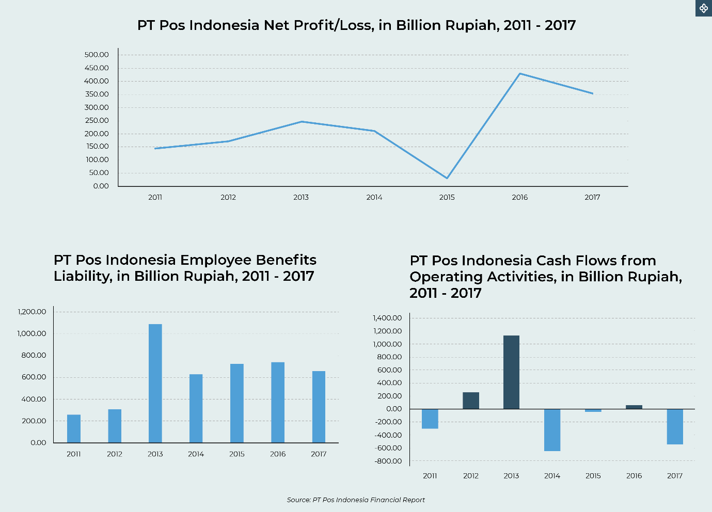

Besides the cashflow issue, Pos Indonesia has a serious problem with its employee benefits scheme. Following the adoption of Financial Accounting Standard No. 24 concerning postemployment benefits in fiscal year 2013, Pos Indonesia’s employee benefits liability soared to Rp1.08 trillion from Rp309 billion in the previous year. After that, the management tried to trim its employee benefits liability, but the strike launched by the SPPI-KB earlier this year suggests that effort faces a serious challenge.

A high official from Pos Indonesia said the country’s postal service had been undergoing significant technological transformation in its parcel sortation system through the adoption of robotic and digital technology since November 2017. This transformation began to pay off in the last quarter of 2018, in which the state-owned postal service started to book a profit after recording a loss in the previous quarter.

The technology adopted is an automated sortation machine manufactured by GreyOrange, the Linear Sorter. GreyOrange’s Linear Sorter has 15 robotic arms to sort parcels. Using data on parcels’ dimensional weight, size and destination postal code that are available in each parcel’s unique barcode, the Linear Sorter can sort 40 parcels per minute. The machine is installed at Pos Indonesia’s main office in Lapangan Banteng, Jakarta.

Another source said the machine helped Pos Indonesia in the era of rapidly growing e-commerce transactions. Every day, it sorts parcels from various e-commerce marketplaces, such as Blibli, Lazada and JD.id. The source does not believe that Pos Indonesia is on the verge of bankruptcy, as claimed by Rieke Diah Pitaloka.

Besides income from parcel delivery, Pos Indonesia also receives commissions from the use of its postal infrastructure in Eastern Indonesia by private courier service providers like Tiki JNE and J&T Express. “Rather than establishing their own infrastructure, it is more beneficial for those companies to use Pos Indonesia’s more than 4,500 postal offices located in all districts of Indonesia,” the source said.

Nevertheless, Pos Indonesia is struggling with motivating its employees to keep pace with change brought about by developments in digital technology.

Issue Update: Palace rejects Arviyan Arifin for PLN top post
OVERVIEW
The State Palace has reportedly rejected the nomination of Arviyan Arifin to lead state-owned electricity company PLN because of his role in causing Bank Muamalat’s deep financial difficulties. The State-Owned Enterprises Ministry will need to propose another name to President Joko “Jokowi” Widodo.

State-owned steel manufacturer Krakatau Steel president director Silmy Karim and state-owned railway operator KAI president director Edi Sukmoro have been said to be viable candidates to lead PLN. (see What we’ve heard). The approved candidate would replace Sofyan Basir, who has become embroiled in the Riau-1 power plant corruption case.

Tenggara Backgrounder reported on July 26 that State-Owned Enterprises (SOEs) Minister Rini Soemarno had reportedly proposed Arviyand Arifin, currently president director of state mining company Bukit Asam (PTBA), to President Jokowi as the sole candidate for the PLN president director position.

Arviyan was actually not Rini’s first choice. She had offered the position to several people, including PLN acting president director Djoko Rahardjo Abumanan and former telecom company Telkomsel president director Alex Sinaga, but they refused to take up the mantle.

The reluctance of some of the names approached by Rini was allegedly due to the criminal tendency that might befall the leader of the company that monopolizes the supply of electricity in Indonesia. Suspended PLN president director Sofyan Basir is currently facing trial for his alleged role in a bribery case pertaining to the Riau-1 power plant. His predecessor Nur Pamudji is also embroiled in another alleged corruption case related to the procurement of high-speed diesel (HSD) fuel by PLN.

The cases plaguing Sofyan Basir and Nur Pamudji have drawn criticism from some quarters as the cases are considered weak.

The Corruption Eradication Commission (KPK) has indicted Sofyan for allegedly facilitating bribery relating to the Riau 1 coal-powered power plant. The KPK accused Sofyan of facilitating meetings between Golkar Party politicians Idrus Marham and Eni Maulani Saragih and businessman Johannes Budisutrisno Kotjo, who was seeking to win the bid for the Riau 1 project, and that Sofyan knew that Idrus and Eni would accept bribes from Johannes.

The indictment states a slightly different charge from when the antigraft body named Sofyan a corruption suspect in April on the grounds that he accepted bribes from Johannes to push the deliberation of the Riau-1 power plant project. The change in the charge was reportedly made because the KPK could not find evidence that Sofyan had accepted a bribe.

Sofyan’s predecessor Nur Pamudji’s case is different but has faced a similar fate. The National Police’s criminal investigation department (Bareskrim) announced in July 2015 it had named Nur Pamudji, who received the prestigious 2013 Bung Hatta Anti-Corruption Award, as the sole suspect in the HSD graft case. But Bareskrim only issued the investigation warrant against Nur Pamudji in August 2017.

Since then nothing happened to Nur Pamudji until last June when Bareskrim surprised many by detaining Nur Pamudji. In a press conference to announce Nur’s arrest, the police displayed a pile of money, said to amount to Rp 173 billion (US$12.24 million), confiscated from PT Trans-Pacific Petrochemical Indotama’s (TPPI) bank account as evidence. This money, however, reportedly had nothing to do with the case. (see Backgrounder, July 19 edition).

Former National Police deputy chief Oegroseno, now PLN commissioner, said the HSD fuel procurement case was not a corruption case. The Corruption Eradication Commission (KPK) has also stated that this case does not concern corruption. According to a source at PLN, Vice President Jusuf Kalla intervened in Nur Pamudji’s case and the police reportedly suspended his detention.

According to a source at the State-Owned Enterprises Ministry, the State Palace crossed out Arviyan Arifin after officials at the palace asked for advice from Financial Services Authority (OJK) chairman Wimboh Santoso regarding Arviyan’s track record, as Arviyan previously had a career in banking before becoming Bukit Asam president director.

The source said Wimboh considered Arviyan to not be the right candidate to lead PLN. Arviyan Arifin is one of those who contributed to the near collapse of Bank Muamalat. When he was Muamalat president director from 2009 to 2014, he funded a substantial amount of corporate credits, including to several mining companies. These loans to mining companies defaulted recently and have caused troubles for Indonesia’s first Islamic bank.

An official at the State Palace confirmed the removal of Arviyan’s name as a PLN president director candidate. Arviyan was considered to lack the necessary strength in enforcing good corporate governance. Moreover, PLN needs a strong figure to settle the company’s many problems — from the auction process to the procurement of power plant projects.

After the Bukit Asam director’s name was removed, the State-Owned Enterprises Ministry was said to have considered other candidates. The two strongest candidates are said to be Silmy Karim and Edi Sukmoro. Silmy has a good record from his previous postings in state-owned weapon producer Pindad and state-owned machine manufacturer Barata Indonesia. However, he is now facing a huge problem at Krakatau Steel. Edi Sukmoro, meanwhile, had a long career in PLN before being appointed KAI president director.

Govt gives Pertamina three-year transition to operate Corridor
OVERVIEW
The government has given its blessing to US oil and gas company ConocoPhillips to remain the operator of the onshore Corridor block in South Sumatra until 2026, indicating that the government is not confident with state-owned oil and gas holding company Pertamina to manage the block when its contract expires in 2023.

Our source from the Upstream Oil and Gas Regulatory Special Task Force (SKK Migas) said that the reappointment of ConocoPhilips as the operator of the Corridor block after the contract expired in 2023 was a middle ground before the operatorship of the oil and gas area was handed over to Pertamina starting in 2026 (see What we’ve heard). SKK Migas did not want to take a gamble with Pertamina after its takeover of two other major oil and gas blocks – the Mahakam block in East Kalimantan and Rokan in Riau – had resulted in a drop in output, especially in Mahakam. Oil output in Mahakam reached only 85 percent of the government target, while gas lifting was even lower at 61 percent as of last April.

Global energy consultant Wood Mackenzie sees the decision as “a new pragmatism at play from the Indonesian government following recent national elections, acknowledging the importance of international oil company [IOC] experience. And it indicates that retaining IOC expertise and capital is once again on the government’s radar.

According to Energy and Mineral Resources Ministerial Regulation No. 23/2018, financial capability to manage oil and gas blocks is one of the things the government takes into account in considering granting oil and gas firms or Pertamina a permit to manage a working area that is about to expire.

The financial capability of Pertamina has come into question since the company took over the Mahakam and Rokan blocks. Pertamina has to spend $1.8 billion to manage the Mahakam block alone. Unfortunately, since the block has been managed by Pertamina, its production has dropped significantly, hampering the return of Pertamina’s investment.

An official from the Upstream Oil and Gas Regulatory Special Task Force (SKK Migas) said Energy and Mineral Resources Minister Ignasius Jonan did not dare to take risks by immediately handing the Corridor block to Pertamina. He did not want a repeat of the Mahakam block incident. Moreover, the ministry’s performance is under scrutiny by President Joko Widodo, especially regarding the huge trade deficit in the oil and gas sector during the first half of this year.

Jonan’s decision to give the operatorship of Corridor to Conoco is apparently in line with the view of SKK Migas head Dwi Soetjipto, but against the opinion of his deputy Arcandra Tahar, who has suggested that Pertamina be prioritized. Archandra and Dwi reportedly could not get along after their differences in handling the Masela project in Maluku.

Dwi argued that if Corridor was given to Pertamina immediately, there would be no American oil companies operating major oil and gas fields in Indonesia. Moreover, sources said, Chevron, another American oil company, is planning to leave its IDD project in the Makassar Strait.

Another source at SKK Migas said that Conoco had long requested the extension of the Corridor contract, but the Energy and Mineral Resources Ministry asked each contractor in the consortium in the Corridor block – Conono, Pertamina and Repsol – to submit a proposal. Our source said the proposal submitted by Pertamina was the worst, with a signature bonus far below US$100 million, lower than those offered by Conoco and Repsol. Finally, all three contractors negotiated to make a joint proposal. This proposal was what the ministry finally approved.

Global Macro: The Fed delivers rate cut, but Powell’s speech disappoints market
OVERVIEW
The United States Federal Reserve cut the Fed Funds Rate by 25 basis points (bps) to the 2–2.25 percent range following the Federal Open Market Committee (FOMC) meeting from 30–31 July. Nevertheless, the market reacted unfavorably with a selloff. For example, the Dow Jones Industrial Average (DJIA) was down by 333.75 points or 1.23 percent after the Fed rate cut announcement. The S&P500 shredded 1.09 percent, and the Nasdaq composite slipped by 1.19 percent.

The selloff was caused by a hawkish statement from the US Federal Reserve chairman Jerome Powell, in which Powell described the fed rate cut as a “midcycle adjustment”, meaning the Fed is not shifting to an aggressive rate-reducing monetary policy. Traders that were expecting the Fed to pursue aggressive rate cuts are disappointed. Morgan Stanley’s analyst derides it as a hawkish cut.

However, economists who have been arguing that the Fed has no strong reasons to cut rates are not surprised by Powell’s confusing statement. Some of them, such as Grant Thornton chief economist Diane Swonk, even suspect the cut was done at the expense of the Fed’s independence. Instead of standing firm against the call from US President Donald Trump for a Fed rate cut ahead of the 2020 presidential election, the Fed gave in to Trump’s demand.

Former Federal Reserve chairman Alan Greenspan disagrees. In defense of Powell’s decision, he said it was important for the Fed to do “insurance cuts” on a few occasions. By insurance cut, Greenspan means that the Fed needs to anticipate the possibility of an economic downturn – even when the probability of such an event occurring is small – by cutting rates at the earliest indication. Greenspan did it on two occasions, specifically in 1995 and 1998. (see What’s More)

Alan Greenspan is a controversial figure. His 17 years of service as the Federal Reserve chairman gave him a highly respectable reputation among the financial press and fellow economists.

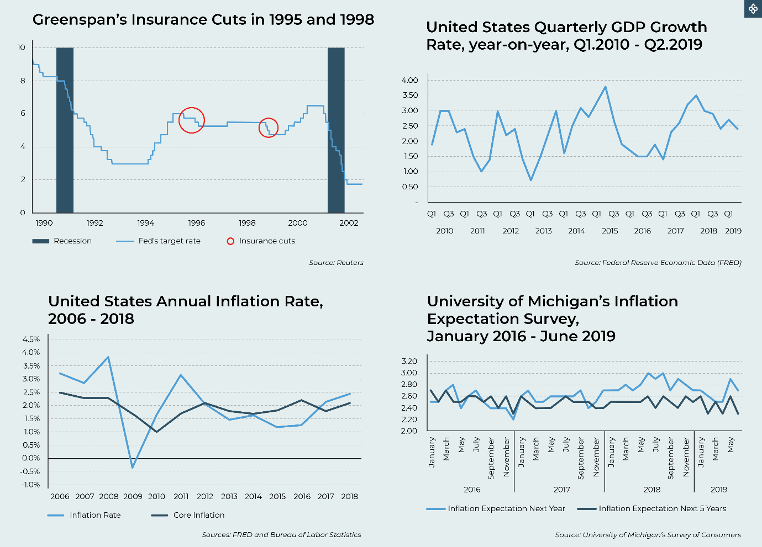

Nevertheless, his repeated denial of the existence of the housing bubble that led to the financial crisis of 2007–2008 tarnished his reputation. Economics Nobel laureate and New York Times columnist Paul Krugman is critical of Greenspan’s professional reputation as an economist.

Nevertheless, Greenspan’s commentary deserves consideration by checking the US economic data. The US quarterly GDP data show that the US economy is cooling down, perhaps by the prolonged trade war between the US and China. Although aggregate inflationary pressure has been building up since 2017, stable core inflation suggests that rising inflationary pressure in the past three years has been driven by fluctuating food and energy prices. More importantly, inflation expectation showed signs of softening after September last year. Early indications of downward economic growth combined with softening inflation expectation might justify the Fed’s case for an “insurance cut”.

In the future, the Fed’s insurance cut might evolve into a dovish but cautious monetary policy. The most likely cause is none other than the worsening US-China trade war. In a surprise move, President Trump escalated the trade war by imposing a 10 percent tariff on another US$300 billion of Chinese exports to the US starting September 1.

Tenggara Strategics is a business and investment research and advisory institute established by the Centre for Strategic and International Studies (CSIS), The Jakarta Post and Prasetiya Mulya University. Combining the capabilities of the three organizations, we aim to provide the business community with the most reliable and comprehensive business intelligence related to areas that will help business leaders make strategic decisions.
  PT Trisaka Wahana Tenggara  The Jakarta Post Building  Jl. Palmerah Barat 142-143  Jakarta 10270  +62 21 5300476/8 ext. 2009  info@tenggara.id  www.tenggara.id | Board of Commissioners:  Jusuf Wanandi, Djisman S. Simandjuntak, Endy M. Bayuni  Board of Directors:  Riyadi Suparno, Phillips J. Vermonte,  Deddi Tedjakumara  Guarantor: Riyadi Suparno  Researchers & Writers:  Astria Zahra Nabila, Adinova Fauri, Bayu Tegar Perkasa, Benni Yusriza, Camilia Adianti, Dwi Atmanta, Frans Surdiasis, Stella Kusumawardhani, Lionel Priyadi, Vincent Lingga, Yesaya Christianto, Yessy Rizky

Disclaimer:
Tenggara Strategics always aims to use reliable sources in providing our best analysis to our clients, and is not responsible for any errors, inaccuracies and/or viewpoints in the original source material upon which we have based our analysis. The analysis contained in this document is intended exclusively for our clients who have subscribed to this service, and is not for public consumption or dissemination.

Nothing contained herein shall to any extent substitute for the independent investigations and the sound technical and business judgment of the reader. In no event will Tenggara Strategics, including its employees, be liable for any decisions made or actions taken in reference to the information contained in these documents, or for any incidental, consequential, indirect, special or exemplary damages, including damages from loss of profits or opportunities, even if advised of the possibility of such damages.

See our 26th July edition Backgrounder
Tribunnnews.com “Jawaban Pramono Anung saat Ditanya soal Dirinya yang Dijuluki ‘Menteri Titipan Ibu’” 24 November 2018 https://tinyurl.com/y38a55z8
See note 1
Tirto.id, “Pramono & Budi Gunawan: Dua Ajudan Megawati yang Paling Moncer” 14 July 2019 https://tinyurl.com/y3zy3rt8
See our 19th July 2019 edition of Backgrounder
Thejakartapost.com, “Budi Gunawan lays groundwork for Jokowi’s second term” 29 July 2019 https://tinyurl.com/yxfhlfxl
Detik.com, “PKB Nilai Lukman Gagal di Kemenag: Parkirannya Jelek, Apalagi Menterinya” 20 July 2019 https://tinyurl.com/y4zfoffu
Kompas.com, “Ini 5 Kementerian dengan Anggaran Tertinggi Tahun 2019” 18 August 2018 https://tinyurl.com/y5fosqz5
Thejakartapost.com, “Suryadharma gets 6 years for haj scam” 12 January 2016 https://tinyurl.com/yy5rbxol
Detik.com, “Cak Imin Tegaskan Koalisi Jokowi Solid: Jangan Saya dan PPP Diadu-adu” 22 July 2019 https://tinyurl.com/y6bhuoq7
Brilio.net, “NU minta jatah menteri: dukungan Nahdliyin ke Jokowi tak gratis” 20 June 2019 https://tinyurl.com/yxu662yc
Nasional.kompas.com, “Kata Jokowi, Izin FPI Mungkin Diperpanjang jika Tak Sejalan dengan Negara” 28 July 2019 https://tinyurl.com/y5cnw386
Change.org, “Dukung FPI terus eksis”
Tirto.id, “Kisah Kedekatan Wiranto dan Rizieq Shihab” 12 February 2017 https://tinyurl.com/yyhtjftb
Tirto.id, “Aksi 112: Semulai Pawai, Berubah Jadi Istigasah” 10 February 2017 https://tinyurl.com/yxevowos
Republika.co.id, “Rieke perjuangkan Pos Indonesia dari ancaman pailit.” 18 July 2019 https://tinyurl.com/y3dcpo66
Kumparan.com, “PT Pos diisukan kesulitan keuangan, Kementrian BUMN angkat bicara.” 22 July 2019 https://tinyurl.com/yxzq32lj
Kumparan.com, “Isu kesulitan keuangan hambat kerjasama PT Pos dengan mitra finansial.” 22 July 2019 https://tinyurl.com/y4vfsmky
CNNIndonesia.com, “Melawan senja kala PT Pos Indonesia.” 25 July 2019 https://tinyurl.com/yygmlxn6
Tirto.id, “Didemo serikat pekerja, ada apa dengan PT Pos?”7 February 2019 https://tinyurl.com/y3ustlax
Koran Tempo, “Penyidikan Kasus Korupsi Nur Pamudji Dipersoalkan,” 5 July 2019 p. 29 https://tinyurl.com/y3nzp8sg
The Jakarta Post, “KPK indicts PLN’s Sofyan for facilitating bribery,” 25 June 2019. https://tinyurl.com/y272gaaa
Katadata.co.id, “Pertamina Sebut Produksi Blok Mahakam Turun Akibat Kendala Pengeboran,” 15 May 2019. https://tinyurl.com/y5uj5yja
The Jakarta Post, “Recent energy deals signal postelection ‘pragmatism play,” 25 July 2019.
CNBC.com, “The two words from Jerome Powell that rocked the financial markets.” 31 July 2019 https://tinyurl.com/y5sw4j7q
CNBC.com, “Dissenters underscore the Fed’s independence: Economist.” 1 August 2019 https://tinyurl.com/y5kr3l3a
Reuters.com, “With Fed’s ‘insurance’ cut, Powell takes cue from Greenspan.” 1 August 2019 https://tinyurl.com/y27kqzzu
NYTimes.com, “The worst ex-chairman ever.” 6 May 2016 https://tinyurl.com/y696owzq
Reuters.com, “Trump: US will hit $300 billion worth of Chinese goods with 10% tariff.” 2 August 2019 https://tinyurl.com/y3l9yyyl

