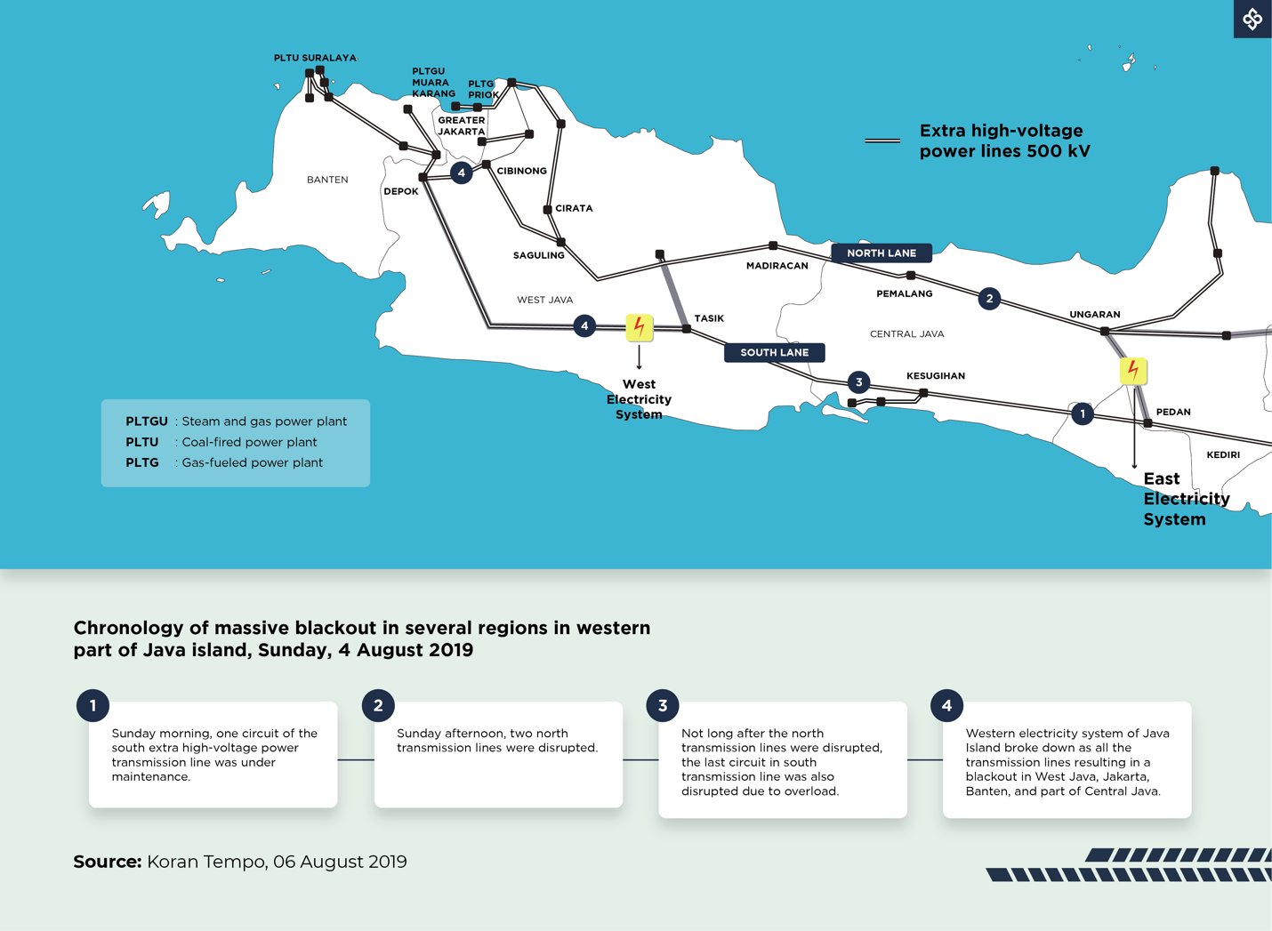

Infographic text:

[Legend]

Extra high-voltage power lines 500 kV

PLTGU: Steam and gas power plant
PLTU: Coal-fired power plant
PLTG: Gas-fueled power plant

West Electricity System
East Electricity System

NORTH LANE
SOUTH LANE

Chronology of massive blackout in several regions in western part of Java island, Sunday, 4 August 2019

1.
Sunday morning, one circuit of the south extra high-voltage power transmission line was under maintenance.

2.
Sunday afternoon, two north transmission lines were disrupted.

3.
Not long after the north transmission lines were disrupted, the last circuit in south transmission line was also disrupted due to overload.

4.
Western electricity system of Java Island broke down as all the transmission lines resulting in a blackout in West Java, Jakarta, Banten, and part of Central Java.

